EEZ PSU H24005 Building Instructions (r5B9)
Work in progress
- PCB assembly
- Firmware uploading

PCB assembly
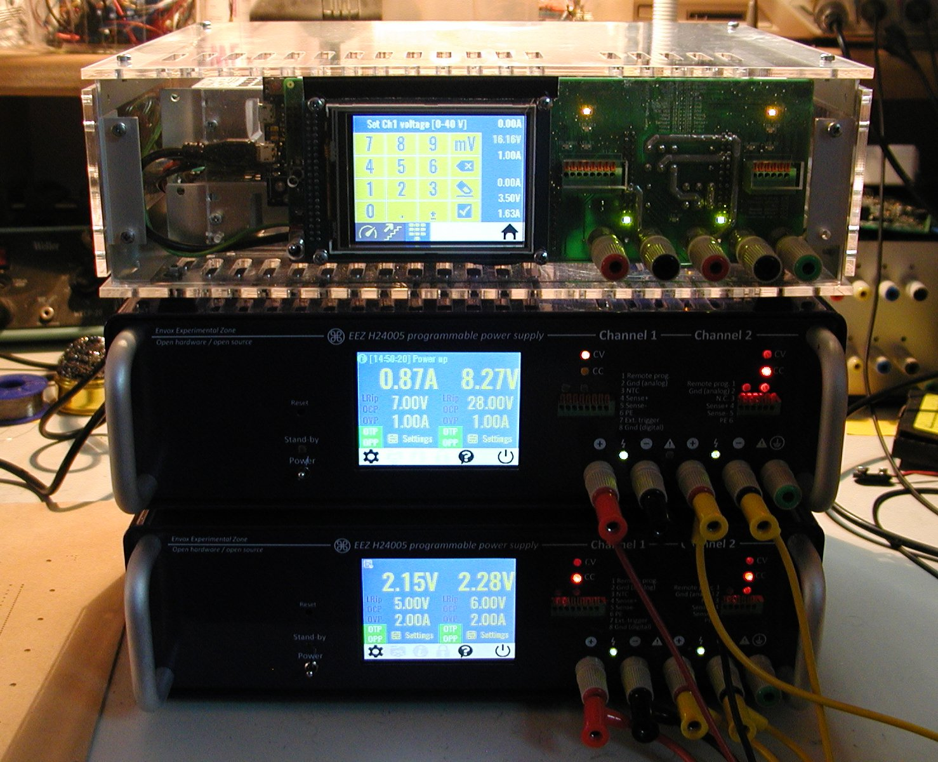Fig. 1: Stacked assembled EEZ PSU H24005 in acryl and metal enclosures
The PSU has four PCBs where SMT parts are used to the greatest extent. Only connectors and few specialized parts (e.g. power resistor, PCB mounted AC/DC adapter, post-regulator's power mosfet, etc.) are THT.
SMT parts are selected to be easily mounted with hand soldering and assistance of magnifying glass with light or low magnification microscope. In general, a magnification of x8 to x10 should be more then appropriate for this task. Almost all passive components are of 0805 size and never smaller then 0603. Selected IC packages are SOIC, TSOP, TSSOP and similar that have exposed pins (i.e. no QFN or BGA package are selected).
Only two ICs (IC1, IC16) that has exposed power tab cannot be simply mounted with soldering iron and need hot air soldering station. That requires different skills but one can find many useful videos on the Internet with instructions how to do that efficiently at home without use of e.g. stencil and reflow owen.

Required tools
- Soldering iron with conical sloped tip example
- Hot air soldering station example
- Solder wire 0.25 mm example, and 0.7 mm example (optionally solder paste, for ICs with exposed power tabs but take into account that its shelf life is very limited even when refrigerated, therefore use small package, example)
- Solder wick / desoldering braid example
- Flux example
- Magnifying glass with light (desktop magnifier with backlight) example or microscope example
- Self-locking tweezers example
- Set of tweezers example1, example2
- Isopropyl alcohol example and paper wipes example for cleaning
- PCB holder example

Test and measurement equipment
The basic tool used for measurement is an oscilloscope. But, if assembling is performed carefully, that no single mistake has been done, (e.g. wrong part value or place, etc.) a simple DMM will be enough to check basic functionality.
During testing and taking measurements please take into account that channel’s negative output (OUT-) is NOT on ground potential. Therefore if you are using multichannel oscilloscope without isolated channels (that is default!) you cannot concurrently connect test probe ground of one channel to the PGND and another one to OUT-. That will interfere with normal operation of CC control loop (IC7, IC8) because the current sense resistor (R69) will be shorted in that way.

Where to start?
The total number of parts that have to be soldered is almost 800. On the first sight that can easily discourage many, but it's not so bad. First, two most demanding PCBs for power boards are identical and you can try to assemble it side by side following steps mentioned below. The AUX PS is the simplest one but also has AC mains section that require additional care when operating. Finally, physically the biggest one – Arduino Shield is modestly populated but also carry extra parts such as TFT touch-screen display, Arduino board, binding posts, etc. that dictate some other set of assembling rules.
A good start could be to check that all parts from the consolidated BOM are available and sorted by type and values and can be easily accessible. As you have probably already learned, simple SMT parts with 2-3 terminals (passives, diode, transistors) can be easily lost even if you have well arranged and clean benchtop. Therefore instead of crying for lost one, simply order few parts more and take another one when previously selected was just gone. That issue is present with both self-locking and regular tweezers.
There is a few methods of storing and sorting SMT parts like small part snapboxes, envelopes etc. Each of them is valuable as far as it can reduce possibility of replacing one part mistakenly with another. That is especially important for ceramic capacitors (MLCCs) that do not carry value marks.
A discipline of selecting a single value at the time (even in larger quantity) and placing them on proper places is of a paramount importance to ensure that PCBs are assembled correctly and will work properly.
When needed tools, bare PCBs and SMT parts are on disposal, one important task still remain before we can start with PCB assembling – it's how to identify part value since PCB's silkscreens (top and bottom) only carry reference designators (i.e. R..., C..., IC..., etc.).
If you are using Eagle then open .brd file and when populating top layer make sure that among other layers 21, 25, and 27 are visible (see Top assembly selected layers.png). For assembling bottom layer set layers 22, 26, and 28 as visible (see Bottom assembly selected layers.png).
The freeware edition of Eagle also allows you to open .brd file and switch layers on and off.
When installation of the Eagle is not an option, you can use the following images:
- AUX PS r5B9 assembly (top layer).png
- AUX PS r5B9 assembly (bottom layer).png
- Arduino shield r3B4 assembly (top layer).png
- Arduino shield r3B4 assembly (bottom layer).png
- Power board r5B9 assembly (top layer).png
- Power board r5B9 assembly (bottom layer).png

Above mentioned order of PCBs is not mandatory for assembling process but represents a logical sequence since AUX PS is required for powering Arduino shield and Arduino shield is required for controlling Power boards. Suggested order is also sorted by PCB complexity starting with the simplest one.
If not otherwise specified, we'd like to recommend that parts are soldered in the following order on the same layer:
- Small SMT parts (e.g. passives, diodes, transistors, etc.)
- SMT ICs
- Bulk SMT parts (elco capacitors, power inductors, mosfets and diodes) and
- THT parts (connectors, switches, chokes, etc.)

Default jumper positions
For various reason on few places on the PCBs a jumpers section are used where zero-ohm resistor is used to define signal path. Some of them define behavior of the circuits (e.g. JP5, JP6, and JP7) and when wired in wrong way or left unpopulated that can create some difficulties and the firmware could not control it properly. To simplify a whole assembly process a clear mark is added next to zero-ohm resistor default position that should insure a proper functionality with current firmware revision. On the picture below above mentioned jumper sections are shown and red rectangle indicate the place for zero-ohm resistor that is in line with “U” shaped mark.

AUX PS r5B9 assembling
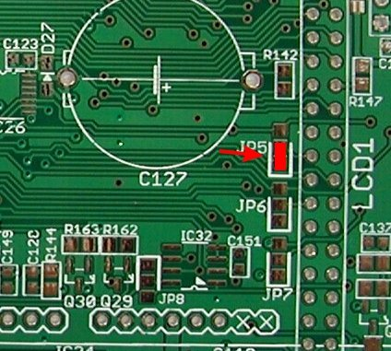Fig. 2: Zero-ohm jumpers markings
Schematic for this board is shown on sheets 6/12 and 7/12. We'd like to recommend the following steps for assembling this board:
- +5 V power supply built around IC16
- Fan control (Q22, X6)
- AC input terminal and protection
- Soft start/stand-by (Q20, Q21, OK1, OK2)
- AC/DC module (TR2) and
- Ethernet and USB terminals (X7, X11)
The IC16 is one of the few parts that require hot air soldering because of exposed power tab placed beneath its plastic body. It has to be mounted in that way to establish a solid electrical and thermal bond with exposed copper on the PCB's top layer. Otherwise, a permanent damage may occur or erratic operation. Due to that this part should be mounted first. When that is done we can proceed with completion of +5 V power supply section. The X5 connector has to be mounted after surrounding SMT parts (D21, R130, R131) otherwise it could be difficult to mount them without damaging X5 by touching it unintentionally with soldering iron body or tip.
When this section is finished and ready for testing do not solder TR2 since it's huge and could make mounting of surrounding parts afterward almost impossible. Instead, use external regulated 12 V supply and connect it properly on its terminal 9- and +7. If everything is soldered correctly, a regulated +5 V will appear on X5 pin 10 (+) and 9 (-).
Now we can proceed with fan control. Keep in mind to mount THT part at the end (X6). Testing of this section has to be postponed until Arduino Shield is assembled. Also, it will require preparation of fan cable which comes without connector.
AC input terminal and protection section contains only THT parts that can be carefully soldered on the bottom layer.
Soft start/stand-by triacs Q20 and Q21 are sharing the same heatsink KK1 mounted on its opposite sides using single screw and nut. They can be mounted on before soldering. Another possibility is to solder heatsink first and then mount on each side a triac and then solder their terminals. Take care that power resistor R107 is of proper type (wirewound) and power rating.
Finally, place TR2 as the latest part on the top PCB layer. Now it's possible to test once again +5 V power supply by carefully applied AC mains on the X4 pin 1, 2 and 5.
On the bottom layer only two parts have to be mounted – Ethernet (X7) and USB (X11) terminals. If you got customized enclosure with pre-drilled holes on its rear panel, we recommend to mount the PCB on the rear panel first (using 14 mm spacers) and then solder that terminals. That will insure that everything fits perfectly.

Arduino Shield r3B4 assembling
There is no recommended order in which sections on this PCB should be soldered. One possibility is to simply follow the order of sheets in consolidated schematics related to this board (sheet 8/12, 9/12, 10/12, 11/12, and 12/12) and to leave the following parts for the end:
- Power relays (K_SER, K_PAR) due to their dimensions
- Super capacitor (C127) for RTC backup
- Push-in connectors (X12, X14) especially if you'd like to follow suggestion to adjust its distance from the front panel as described below
- 40-pin connector (LCD1) for the TFT touch-screen display
- Front panel power switch (SW1)

The revision r3B4 has few issues that we didn't spot before it went into manufacturing but fortunately all of them can be easily fixed.

Red LED polarity
Let's starts with the simplest one which is related to chosen red color LEDs that are located on the PCB's bottom layer. Polarity marking on the PCB is not in line with HSMH-C170 specification. Therefore you simply need to rotate it while soldering.

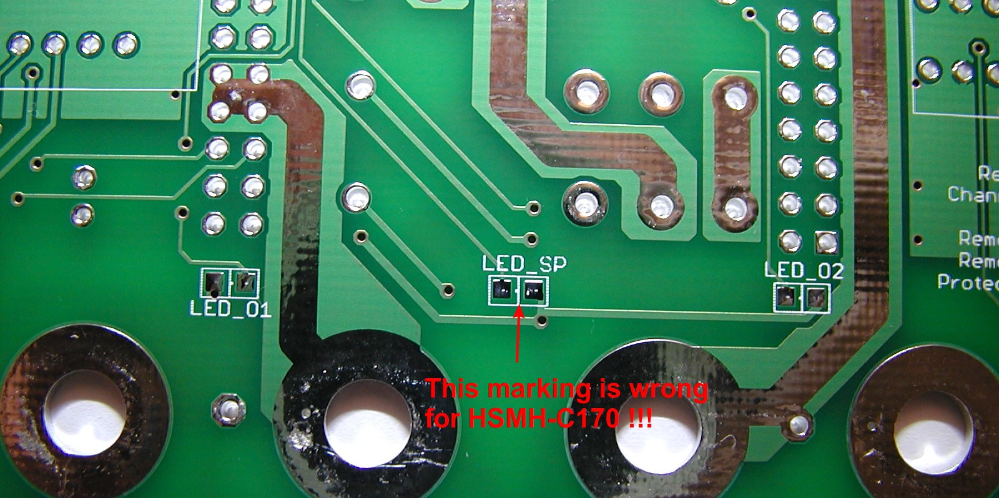Fig. 3: Red LEDs incorrect markings on the Arduino Shield bottom layer
Output capacitors mounting
We are using SMT EEEFK1J220P (22 μF) as output capacitors (C106, C111) that are wider in diameter than THT UPW1J150MED (15 μF) initially specified. The SMT pads provided on that positions are also for SMT capacitors smaller in diameters. Regardless of that, mentioned type can be easily mounted by simply bending its terminals when it becomes a THT. Now, holes for a THT part can be used for soldering.

Additional output capacitors
An additional capacitor is recommended on the power output. A ceramic 1 μF, 50 V capacitor is used and damped with 1 Ω resistor. They should be placed as close as possible to the output binding post holes but there is no predicted place for that on this PCB revision. Nevertheless it's simple to add them as it is shown on Fig. 4.

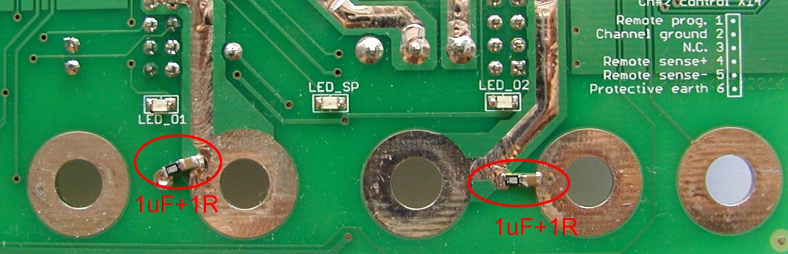Fig. 4: Additional channel's output RC circuit
Ethernet connector position
The Ethernet connector (X18) is not properly positioned – it is too close to the CH1's heatsink. Due to that it is not possible to insert Ethernet cable that connect output terminal on the rear panel (via X8 on the AUX PS board).
A right angle connector has to be used as specified in the BOM. But, when such connector type is used (see Fig. 5), there is no possibility to put a screw to fix TFT touch-screen display on the lower left corner viewed from the display's back (or lower right corner viewed from the display's front).

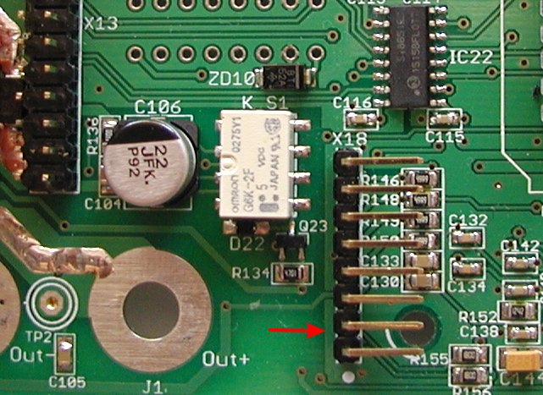Fig. 5: Ethernet header on the Arduino shield
Fortunately that is not a big issue since display still can be fixed on all four corners with 11 mm spacers and that will provide enough mechanical strength required to withstand finger pressure on that part of the display (Fig. 6).

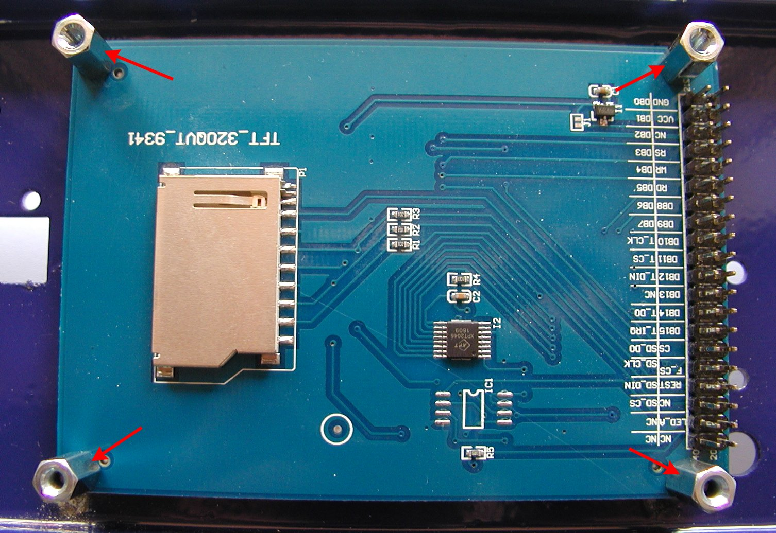Fig. 6: TFT touchscreen display rear view
Push-in connectors distance adjustments
Distance between rear side of the front panel and the Arduino Shield PCB is defined by TFT display that is approx. 18 mm:
- 5 mm display thickness
- 1.5 mm display PCB thickness
- 11 mm spacer between display and plastic washer (defined by LCD1 connector height) and
Height of the push-in connectors (X12, X14) is 14 mm and when they are soldered directly on the PCB they will be 4 mm apart from the front panel surface. That does not mean that their pins are not accessible. It's more a question of visual appearance and you can fix that with modified cheap DIL16 sockets. You need to cut them horizontally and insert each half separately since distance between push-in connector's rows is different. You also need to adjust their height to 4 mm (usually that is about 5 mm). That can be done in a matter of minute using a piece of sandpaper.
Insert push-in connectors into modified sockets before soldering. To improve mechanical strength you can also apply e.g. hot glue.

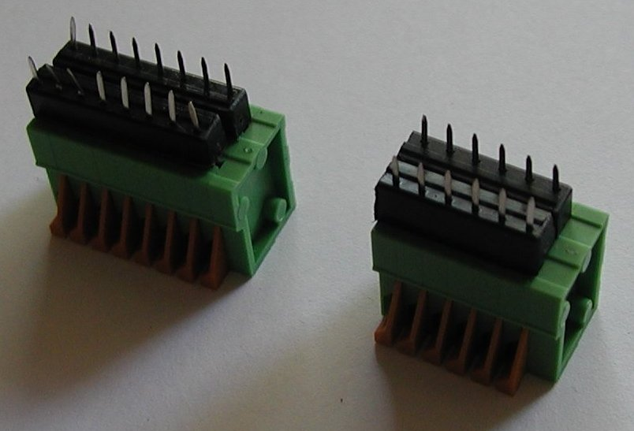Fig. 7: Push-in connectors with extensions
Keep in mind that X12 and X14 have to be mounted on the bottom side of the PCB:

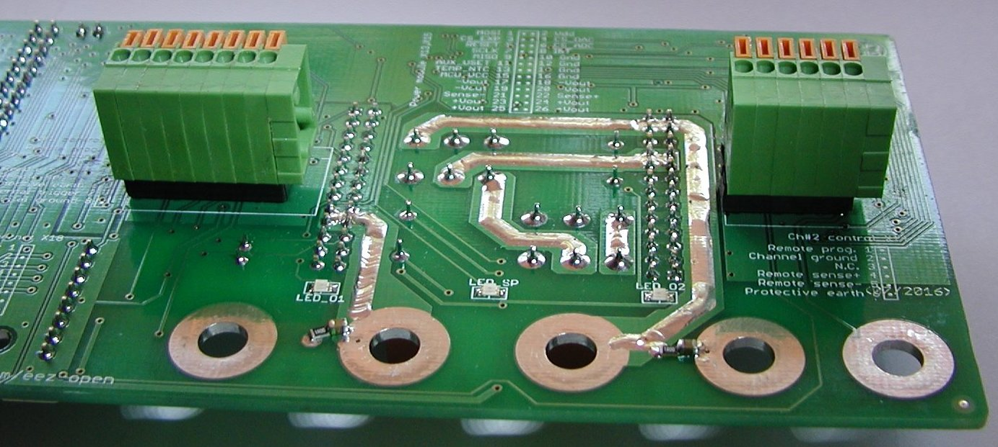Fig. 8: Push-in connectors mounted on the Arduino shield
The end result looks like this:

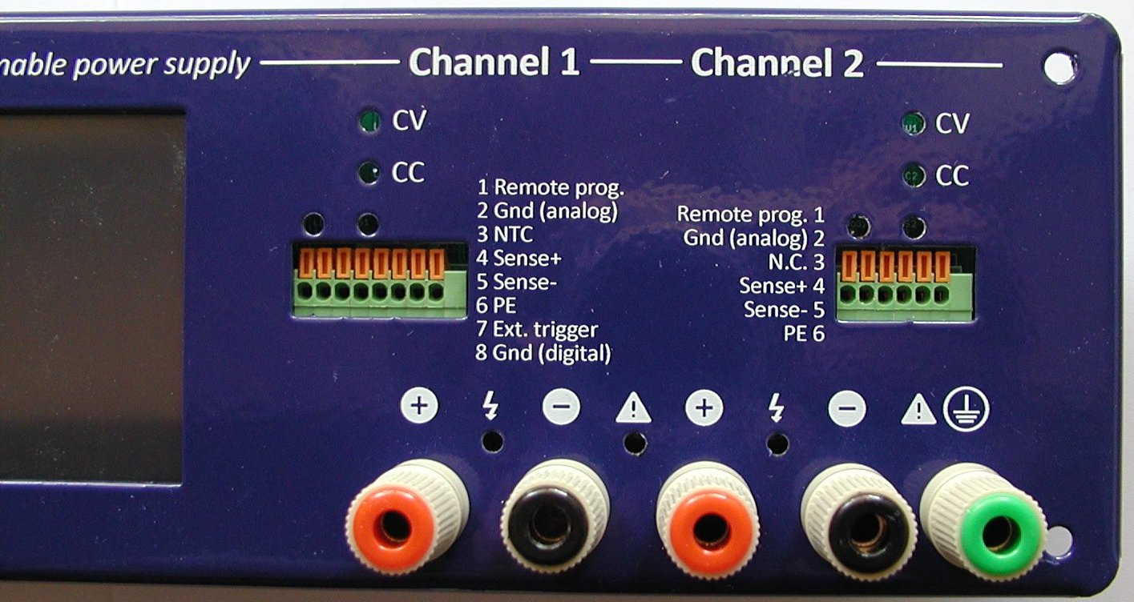Fig. 9: Front panel with push-in connectors mounted
When all SMT parts are mounted, followed by THT parts, we can solder few parts mentioned on the beginning:
- The power relay now should not interfere with mounting of any surrounding parts.
- The super capacitor is polarized as elco capacitors or battery cell. Check its terminals polarity twice before mounting!
- If push-in connectors X12 and X14 is not inserted into sockets, as it's suggested above, then we can now proceed with their soldering on the bottom side of the PCB.
- TFT touch-screen display connector (LCD1) has to be soldered on the bottom side too. If we want to be completely sure that it's aligned with display, we can mount display on the customized enclosure first, then insert 40-pin connector on display's header, and finally place the PCB on top of display. Use plastic washer between 11 mm spacers and PCB and another one between PCB and M3 mounting screw. We have to check alignment of the PCB with output binding posts holes and when everything is in place 40-pin connector can be soldered.
- Finally, we can mount power switch. Once again, it's recommended to see how it's aligned with the corresponding hole on the enclosure's front panel first, then adjust its position and start with soldering.
When all parts are mounted and PCB is properly cleaned, an Arduino Due board can be installed. It has to be loaded with appropriate firmware (M2 or newer) that is configured to work with this board revision. Use its USB named Programming port for firmware upload.
If everything is assembled correctly and firmware is successfully uploaded, the welcome screen should appear after reset or new power on. The firmware will proceed with self-test and check peripherals and channels as defined in conf.h, or override with parameters in the user_conf.h file.
The AUX PS module r5B9 has mistakenly connected pin 1 of the USB header to the USB cable. Therefore even if the PSU is completely switched off, the Arduino shield will be powered from the external source if USB cable is connected. The easiest way to fix that issue is to detach pin 1 (red) wire and insulated it as shown on the Fig. 10.

Power board r5B9 assembling
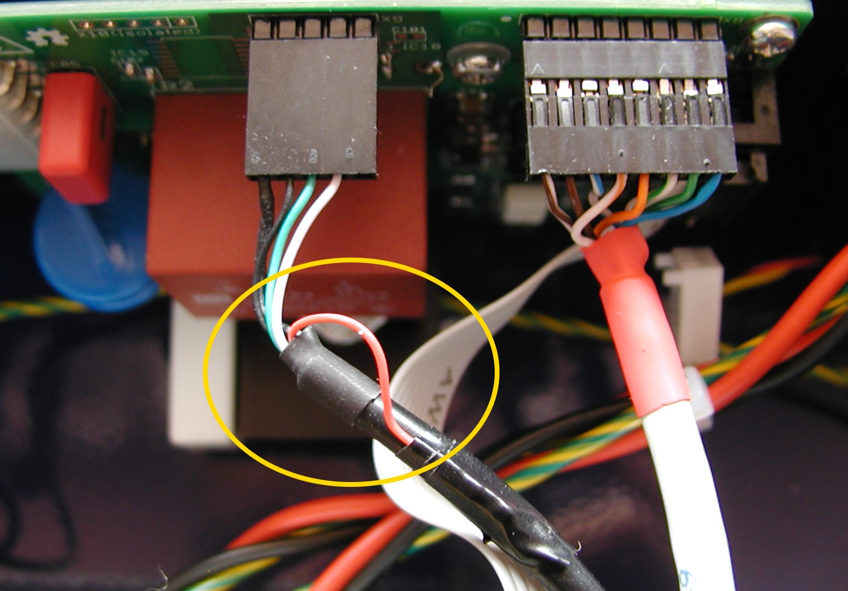Fig. 10: USB cable hack
According to the number of components and functionality, the Power board is the most complex part of this PSU. We'd like to recommend assembling of this board in the following steps:
- Power pre-regulator
- Bias power supply
- Post-regulator
After each section is completed, perform simple testing described below before continuing with the assembling.

Power pre-regulator
The power pre-regulator circuit is shown on Sheet 1/12. We recommend you to start with IC1 that, as in case of IC14, require soldering of exposed thermal pad. A hot air soldering station instead of soldering iron should be used here. This section also require soldering on the PCB’s bottom side (L1 and X1). That should not be a problem if you are using PCB holder. If you choose to supply Power board with AC instead of DC input, follow Hack #1.
Once again, keep in mind to mount all smaller parts first and than continue with bulky one such as L2, C18, C16, etc.
When everything is in place, you can proceed with basic testing. Since the board is not fully assembled, it cannot be done without some tricks. The first possible obstacle to check if pre-regulator works properly is existence of Q3 that is used to enter 100% duty cycle when the pre-regulator is bypassed. The IC1 is then effectively switched off and instead of switching frequency a DC signal will be present on Q1 gate (hence the name 100% duty cycle). But, we’d like to test in this step if switching works or not. We have two possibilities here:
- To apply +5 V (use some external source in this stage) to Q3 gate by soldering a thin wire e.g. used for wire wrap to that position or locate pin 13 on IC9 (see Sheet 4/12) and do the same or
- simply place zero-ohm resistor on position R13. Note: don’t forget to remove it before start testing the Post-regulator section and IC9 is mounted.
Before we can apply input power we need to provide some signal on trace OUT+. The easiest way is to locate any of pins 23 to 26 on X3 connector. Do not solder X3 connector in this stage because you’ll have difficulty with mounting surrounding parts like e.g. R95, R105, C84, Q19, etc.
Again, an external regulated source is needed. We can use the same +5 V used to turn on Q3 or something else with output of up to +40 V. In fact, we can start testing by simply connecting OUT+ to the ground. If OUT+ is grounded we can check with the scope two points to see if pre-regulator works:
First is “hot-spot” (SW, magenta trace) where Q3 drain, power inductor L2 and D5 cathode are connected. Use x10 probe. There is also a place for additional R4 and PCB test point (example) on the PCB where you can hook probe securely. Another test point is PREG_OUT (Preg, cyan trace), output from the power pre-regulator.
Fig. 11 shows measurement when +OUT is set to 0 V (grounded). Its output voltage will vary depending on connected load and difference between post-regulator output, and power pre-regulator output. Mentioned voltage difference could be about +6.5 V for no load to less then +3 V for full load of 5 A. Fig. 12 is another example without load when +5 V is used for pre-regulator’s output voltage programming (measured PREG_OUT is +10.8 V).

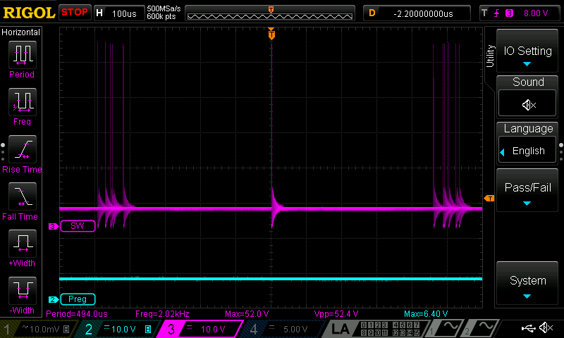Fig. 11: Pre-regulator measurements, +VOUT = 0 V (grounded, no load)
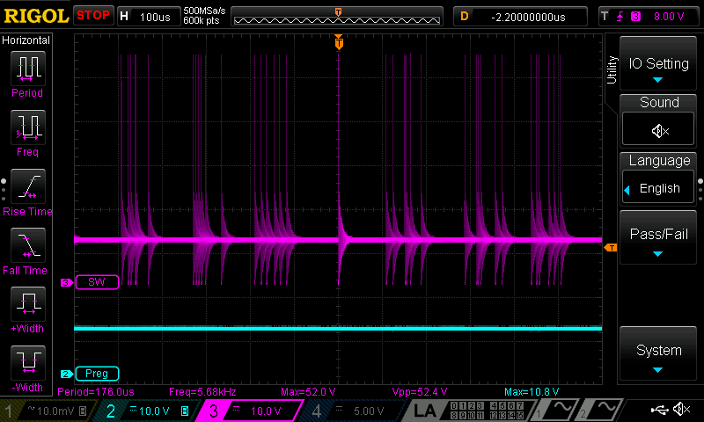Fig. 12: Pre-regulator measurements, +VOUT = 5 V, no load is connected
Please note that in both cases the SW signal looks erratic but that is only because no load is connected. On Fig. 13 is shown characteristic switching pattern when load is connected (e.g. power resistor of 10 Ω).

Finally on Fig. 14 is shown what will happen if Q3 is not turned on. The IC1 will enter 100% duty cycle because chosen values for voltage divider in feedback loop (R12, R15) are set well over pre-regulator input voltage to 56 V while input voltage is not higher then 50 V.
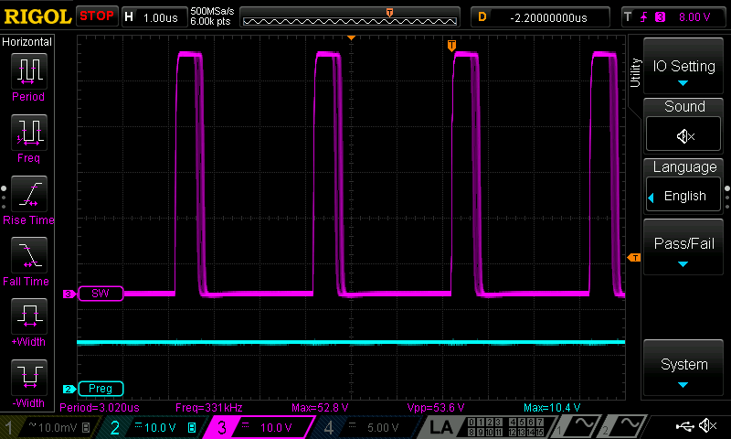Fig. 13: Pre-regulator measurements, +VOUT = 5 V with load connected
If you’d like to test this scenario be sure that no load is connected, otherwise a Q1 SOA could be easily exceeded that can damage Q1 permanently (with unknown consequences for IC1 too).

The so-called Low noise mode of operation when pre-regulator works with 100% duty cycle will remove from channel’s output hard to filter switching noise. But working in that mode puts real limitation in output power and if the PSU will be used for application where higher output ripple can be easily tolerated it’s possible to disable that option by removing Q3 and mount permanently zero-ohm resistor on position R13.
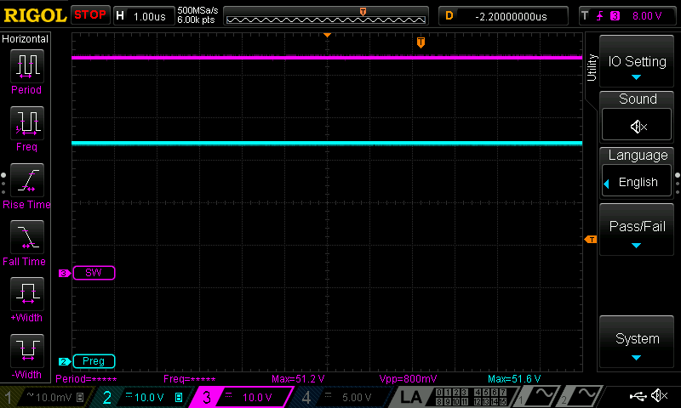Fig. 14: Pre-regulator in 100% duty cycle, without load connected

Bias power supply (switching pre-regulator and LDOs)
The sheet 2/12 has to be followed for bias power supply circuit assembling. It does not require any special instructions and when everything is in place we can proceed with basic testing. Please note that power pre-regulator will be now also powered and make sure that no load remains connected on the PREG_OUT from the previous testing. Obviously, the first thing that we can test are output voltages on points +V (IC2), -V (IC3) and +5V (IC5). They should to be within 5 % tolerance +5 V, -5 V and +5 V.
Another two points of interest are SW (IC4) and PWRGOOD (IC5). The good place for probing SW signal is pin 1 on TR1 or D10 cathode. Fig 15 shows typical waveform on that point:

It’s interesting to see how the PWRGOOD relates to change of input voltage. That signal will be actively monitored with MCU and it will push the PSU into Stand-by mode as soon as possible when its changed from high to low level. Fig. 16 and Fig. 17 shows transition while input power is applied and removed.
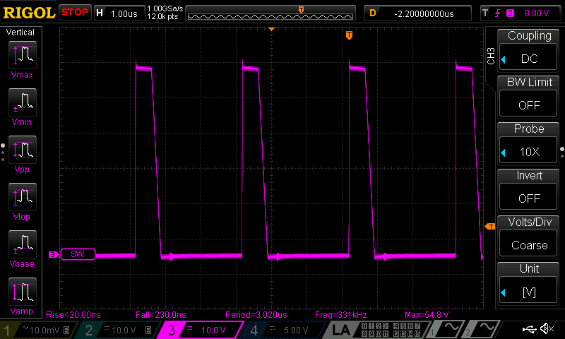Fig. 15: Bias pre-regulator SW output

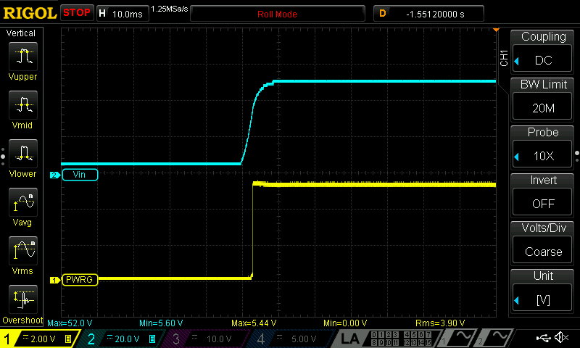Fig. 16: PWRGOOD signal transition (Power on)
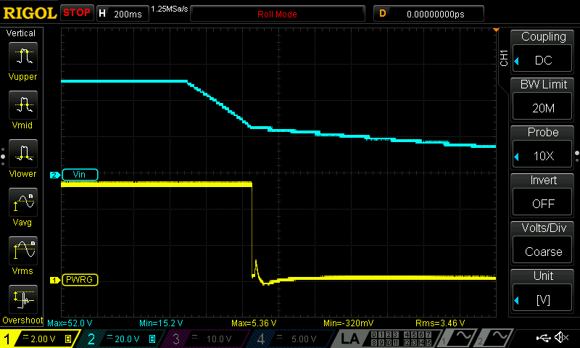Fig. 17: PWRGOOD signal transition (Power off)
Post-regulator
The post-regulator circuits can be found on Sheets 3/12, 4/12 and 5/12. The power mosfet (Q4) require special attention. It’s THT part and before soldering we have to bend its terminals as is shown on Fig. 18.

The Q4 has to be mounted on PCB’s bottom layer, and if EEZ H24005 customized enclosure is used, please ensure that distance between its surface area and PCB bottom side is 5 mm. The easiest way to accomplish that is to mount PCB on the heatsink (Fig. 19) using spacers, then mount Q4 (do not forget insulation!), fix it with M3 screw and then start with its soldering.
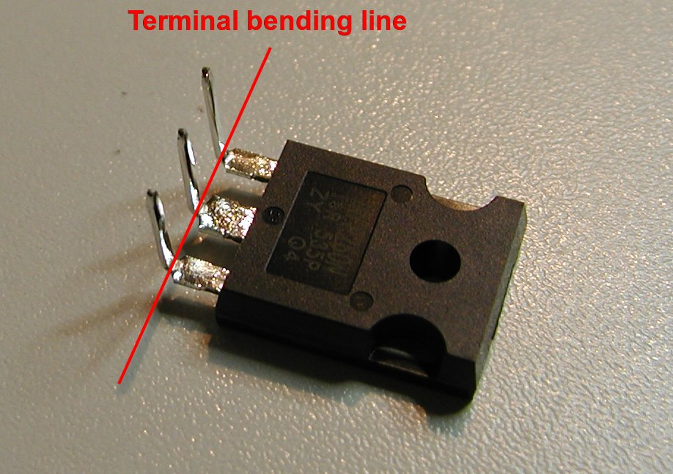Fig. 18: Q4 preparation for mounting

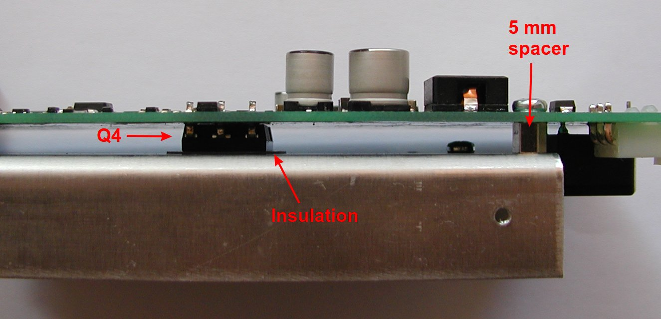Fig. 19: PCB side view with Q4 mounted on heatsink
It is highly recommended that below power pre-regulator section a piece of 5 mm thick silicone thermal pad is mounted (search e.g. AliExpress). Channel temperature that is measured with NTC1 can be lowered in that way significantly. With e.g. 20 mm wide pad (Fig. 20) it’s possible to achieve 6 ºC temperature drop on the max. load. Lowering temperature will also affect cooling fan operation which will work with lower speed and makes it quieter.

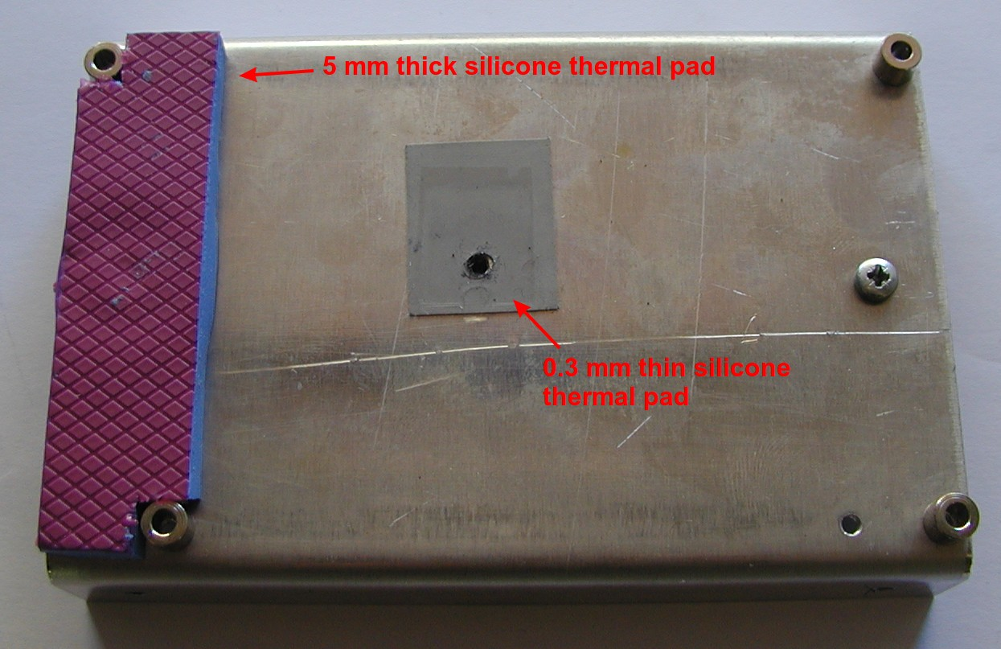Fig. 20: Silicone thermal pads
Do not use conductive thermal pad (e.g. aluminium block with PCB side insulated) since it will drastically increase switching noise!

When everything is mounted, you can check few points before connecting it with the Arduino Shield that is required for controlling the Power board:

Signal | Value | location | Comment
+VREF | +2.5 V | IC10 | Define overall precision
+OUT | around zero | Pin 23-26, X3
CV_ACTIVE | +5.1 V (logical high) | R88/R92 | CV mode active (if U_SERVO is negative)
CC_ACTIVE | +0.6 V (logical low) | R101/R104
POST_OE | +4.67 V (logical high) | R56 | Output is disabled
U_SERVO | -1.1 V | D15 cathode
I_SERVO | +0.28 V | D17 cathode

Corrections
During the assembly and testing two issues are found on this board that will require PCB modifications. Fortunately both can be done without considerable effort or special skills. The simpler one is related to radiated EMI. One of the PCB’s mounting holes is wired to the protective earth potential and the mounted heatsink for the Q4 become also on that potential when it’s fixed on the PCB. Our intention was to attenuate EMI in that way, but the end results is quite contrary when the Power board is mounted into metal (conductive) enclosure! It seems that in that way a whole enclosure is earthed not on one but on three different point (one close to the AC inlet and two via above mentioned wiring of the heatsink) and that generate ground loops.
If you are going to use metal enclosure, it is advisable to simply cut the earth trace that leads to the mounting hole which is near L2 power inductor as shown on Fig. 21. Use miniature drill with a diamond mill (example) for that.

Another issue is connected with selection of the voltage programming source that in our case can be internal (DAC output, IC11) or external signal input (+2.5 V full scale) available via miniature push-in connectors located on the Arduino Shield (X12, X14). Due to the mistake on PCB layout only internal programming (that is default) is possible. To overcome this issue we need to cut U_SET_OUT trace that goes to R52 and connect it to R81 (Fig. 22).
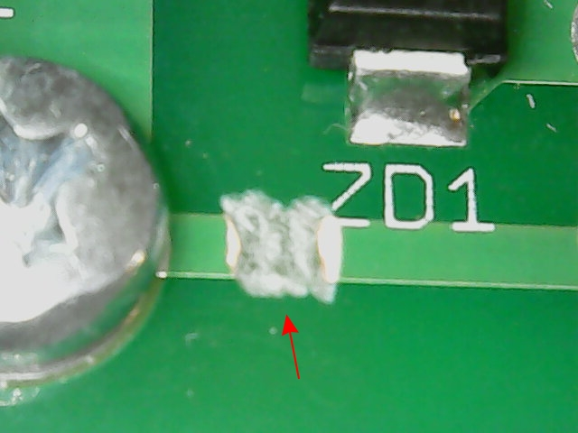Fig. 21: Earth PCB trace cut

A thin wire (e. g. for wire wrap) about 5 mm long is needed to be soldered (Fig. 23, pos. A) and PCB trace has to be cut (Fig. 23, pos. B).
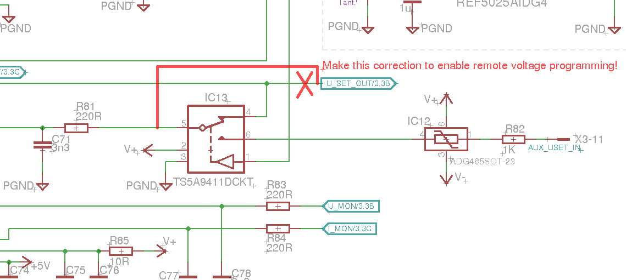Fig. 22: Voltage programming selection schematic modification

Firmware uploading
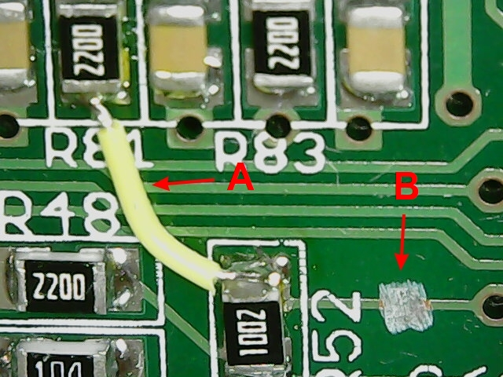Fig. 23: Voltage programming PCB modification
The PSU firmware is an Arduino sketch. Therefore for its compilation and uploading to the Ardunino Due board that resides on the Arduino Shield you have to install and run cross-platform Arduino IDE which can be downloaded here.
Installing Arduino IDE is not enough in our case because support for ARM boards such as Due is not installed by default. Therefore you have to add ARM Cortex-M3 board support. Navigate to Tools… Board:… Boards manager and select for installation Arduino SAM Boards package. When it’s successfully installed, you can check that as shown in the Fig. 24.

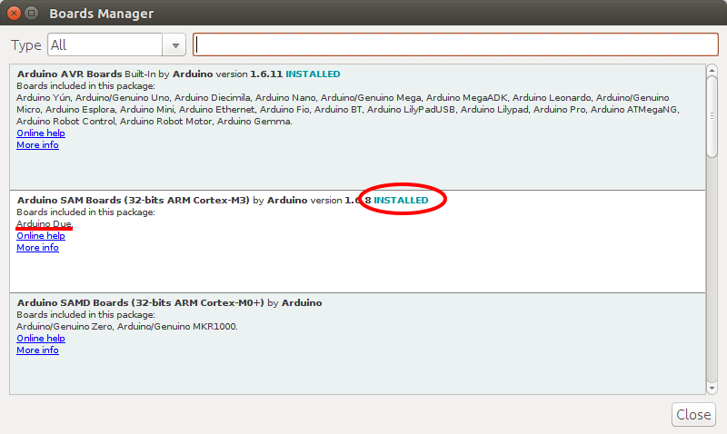Fig. 24: Arduino boards manager with installed support for Due
Next step is selection of Board and USB since Arduino Due board has two USB ports. We’ll use Programming Port as shown on Fig. 25.

The Arduino IDE is now ready for work and we can continue with downloading firmware from the GitHub repository. The Arduino Shield r3B4 or newer require firmware revision M2 that can be found in Master branch.
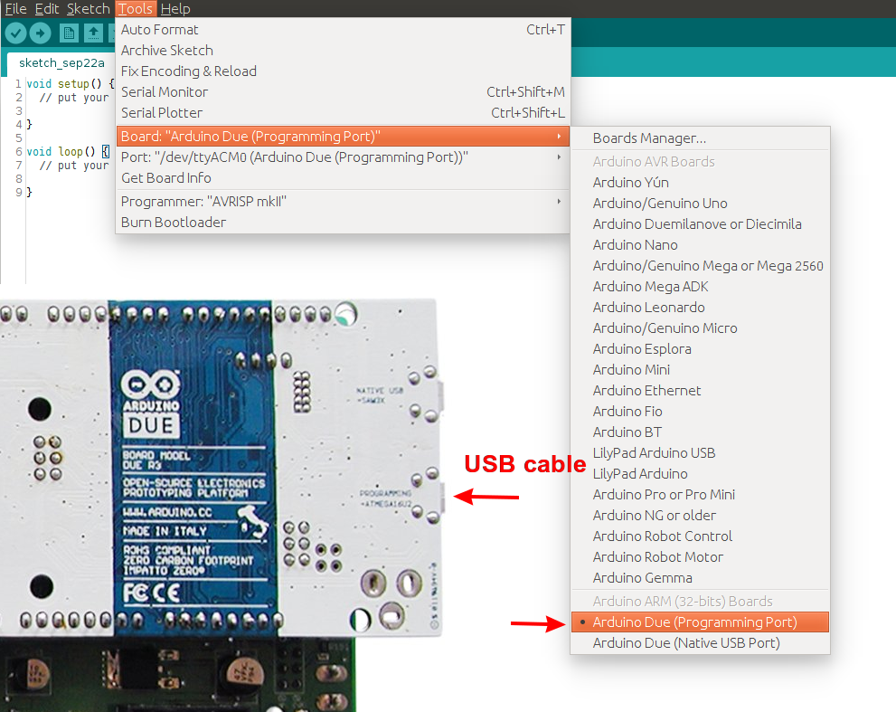Fig. 25: Arduino DUE USB port selection
Move to Clone or download option and select Download ZIP option to save the latest build on your PC (Fig. 26).

When downloaded master.zip package is extracted, the following folder’s tree should be created:
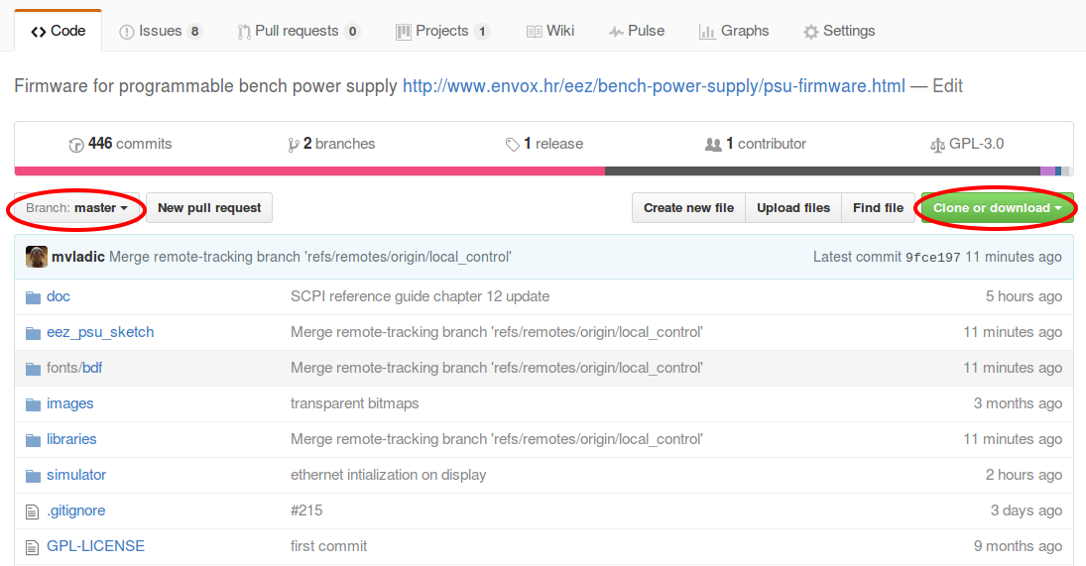Fig. 26: Firmware download

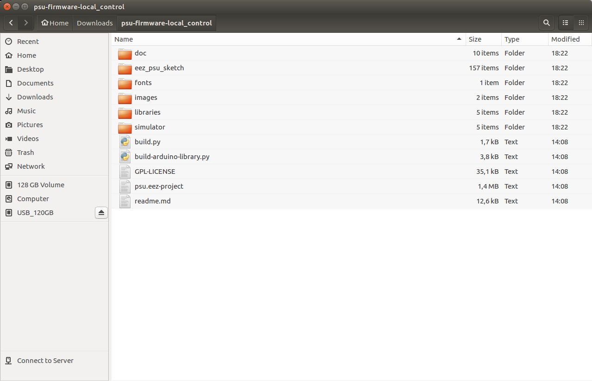Fig. 27: Firmware folders (Ubuntu Linux)
Contents of two folders will be used for firmware compiling within the Arduino IDE: eez_psu_sketch and libraries. The contents of former one has to be copied into Arduino folder that contain 3rd party libraries. That could be e.g. /home/denis/Arduino/libraries on Linux or My Documents\Arduino\libraries on Windows.
The firmware upload require the following steps:
- Power Arduino Shield board
- (Re)start Arduino IDE
- Check if proper USB port is selected under Tools… Port:
- Load firmware sketch eez_psu_sketch.ino (File… Open)
- Start Upload (Sketch… Upload or select the Upload icon on toolbar)
- When the upload process will ends up with an error as shown on Fig. 28 press the RESET button on Arduino Shield board or Arduino Due

- Start the upload procedure once again. If Arduino board is successfully reset upload progress bar will appear after compiling (Fig. 29).
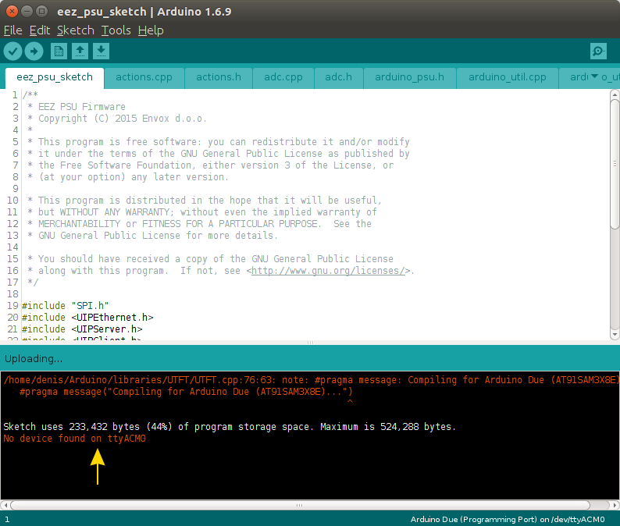Fig. 28: Arduino sketch (firmware) upload error

- You have to reset Arduino once again regardless of the message “CPU reset” that will appear at the end of the uploading process.
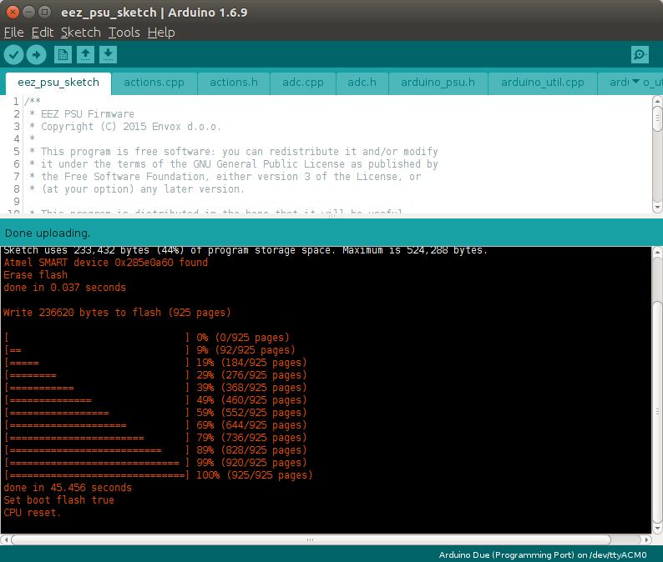Fig. 29: Arduino sketch is successfully uploaded
On first start the initial touchscreen calibration page (Fig. 30) will be displayed otherwise a welcome page (Fig. 31) will be displayed for few seconds. You cannot skip this test since without calibrated touchscreen interaction could be erratic or even impossible.

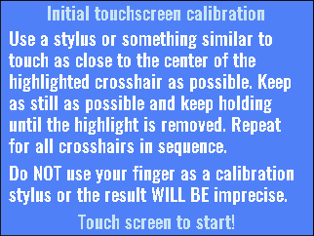Fig. 30: Initial screen calibration on first power on

When initial touchscreen calibration is finished, the self-test will be initiated and it is a good indicator that all control over all circuits can be established. If self-test is passed, no additional message will be displayed, and firmware will proceed with the main page (Fig. 32).
Fig. 31: Welcome page

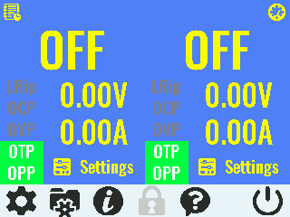Fig. 32: Main page

Work in progress

